

**Problem Statement:**

You work for XYZ Corporation. To maintain the security of the AWS account and

the resources you have been asked to implement a solution that can help easily

recognize and monitor the different users. Also, you will be monitoring the

machines created by these users for any errors or misconfigurations.

**Tasks To Be Performed:**

1. Create a dashboard which lets you check the CPU utilization and

networking for a particular EC2 instance.

And

**Problem Statement:**

You work for XYZ Corporation. To maintain the security of the AWS account and

the resources you have been asked to implement a solution that can help easily

recognize and monitor the different users. Also, you will be monitoring the

machines created by these users for any errors or misconfigurations.

**Tasks To Be Performed:**

1. Create a CloudWatch billing alarm which goes off when the estimated

charges go above $500.

2. Create a CloudWatch alarm which goes off to an Alarm state when the

CPU utilization of an EC2 instance goes above 65%. Also add an SNS

topic so that it notifies the person when the threshold is crossed.

For task1, we need to create a CloudWatch dashboard for an EC2 instance. Let’s create it first.

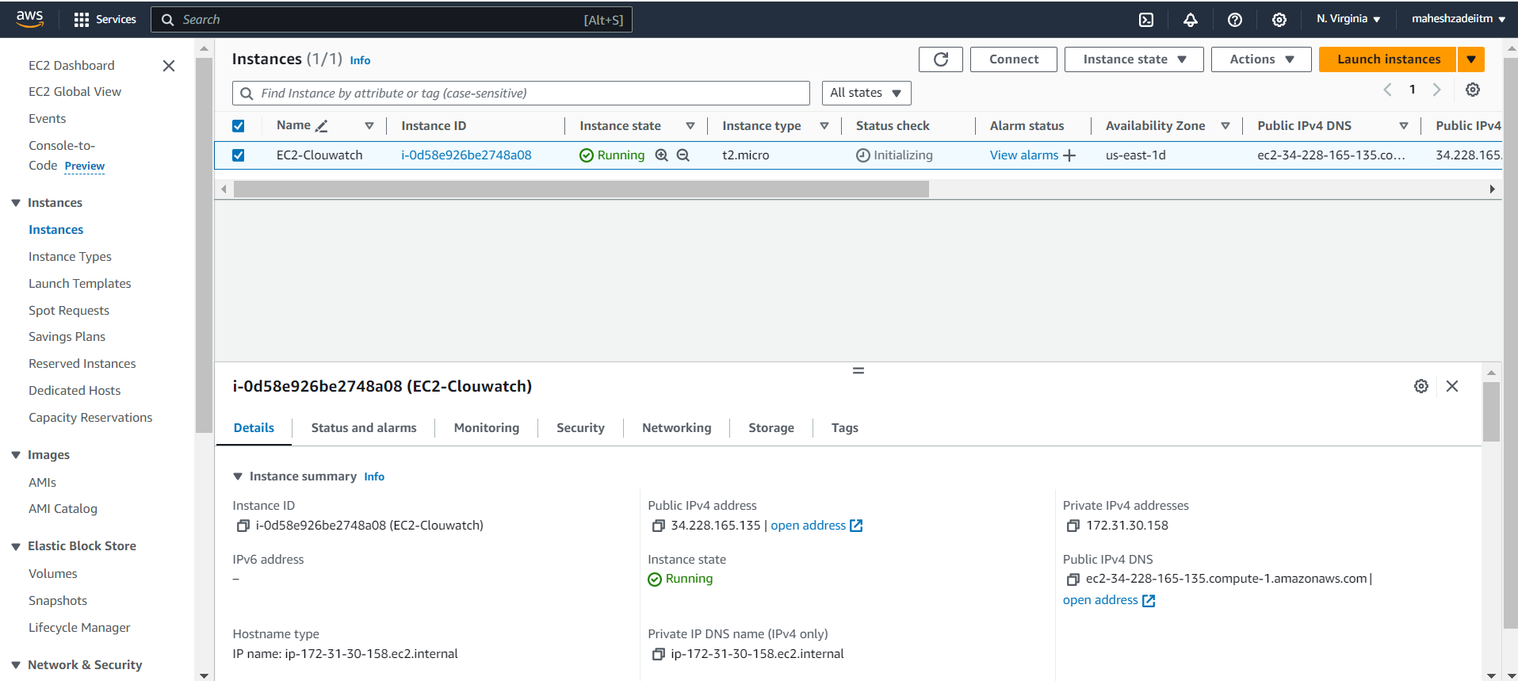

Instance is ready. Let’s create a cloudwatch dashboard

Click on create dashboard

Choose EC2

Select metrics related to CPU utilization and Network and create widget

Widget is added to the dashboard.

Let’s move to the next task - Alarms

Let’s first enable billing alerts in order to create billing alarms.

Go to Billing and Cost Management 🡪 Billing Preferences.

**Enable receive billing alerts and update.**

**Go to cloudwatch dashboard and click on create alarms**

**Select matrix**

**Search for billing and select Total Estimated Charge**

**Select USD and click on Select metric.**

**Click on Next**

**Remove notifications and click on Next**

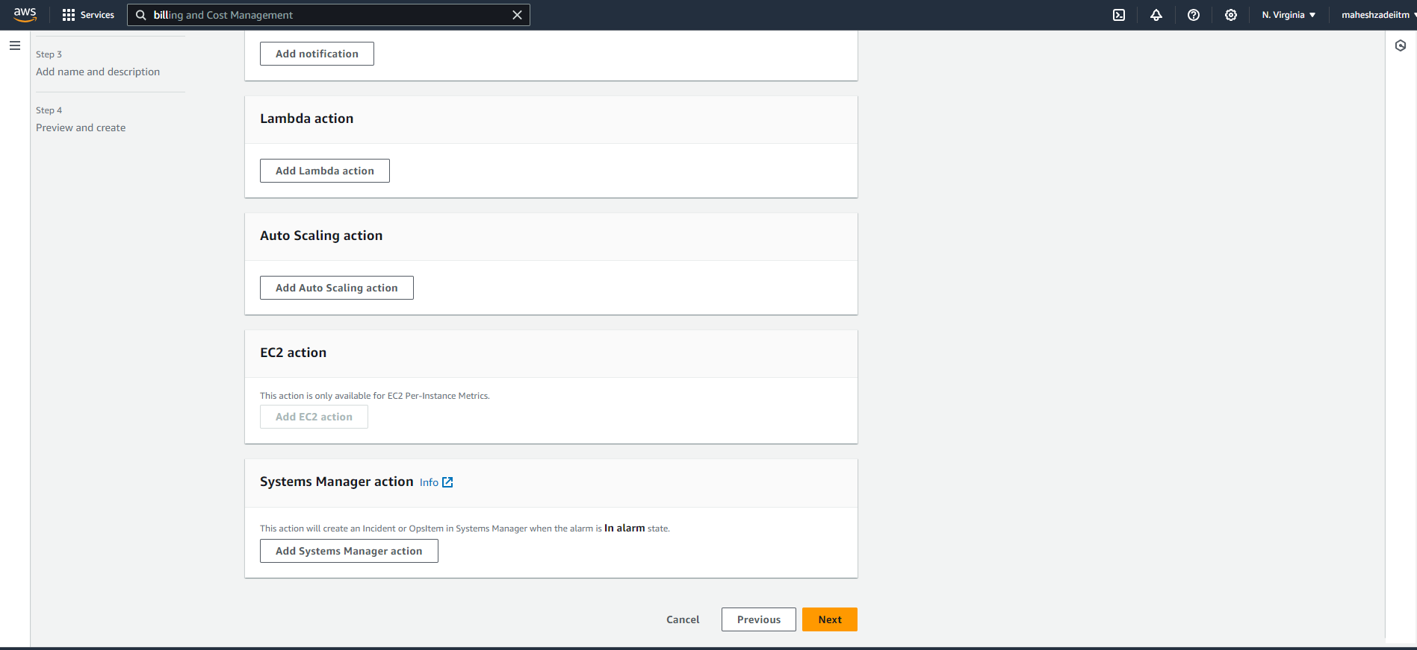

**Give the Name**

**Alarm is created**

**Lets create next alarm for CPU Utilization above 65% with an SNS topic.**

**Go to Create Alarms 🡪 Metric 🡪 EC2 🡪 Per-Instance Metrics 🡪**

**select CPU Utilization for the instance**

**Enter threshold value 65 and click Next**

**Create a new SNS topic. It will send mail once the CPU Utilization reaches 65%.**

**Provide a mail ID**

**Keep the remaining settings as it is and click on Next**

**Lick on create topic**

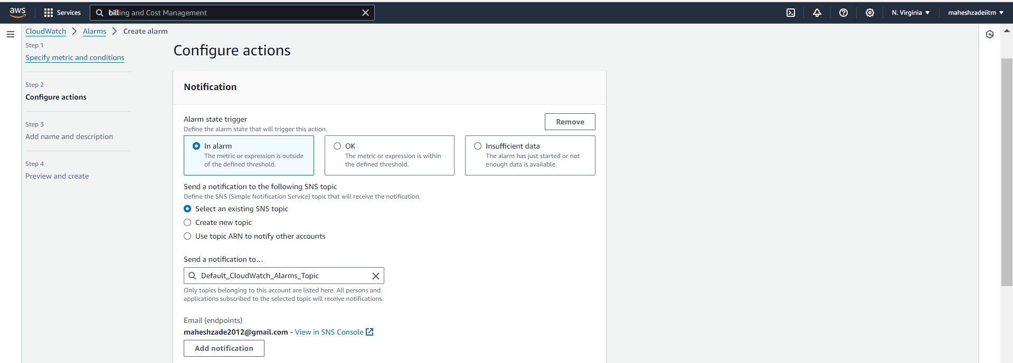

**Give it a name and click on Next**

**Review the settings and Create alarm**

**Alarm is created**

**Alarm is created. Let’s go and subscribe this SNS Topic**

**Open your mail and accept this subscription.**

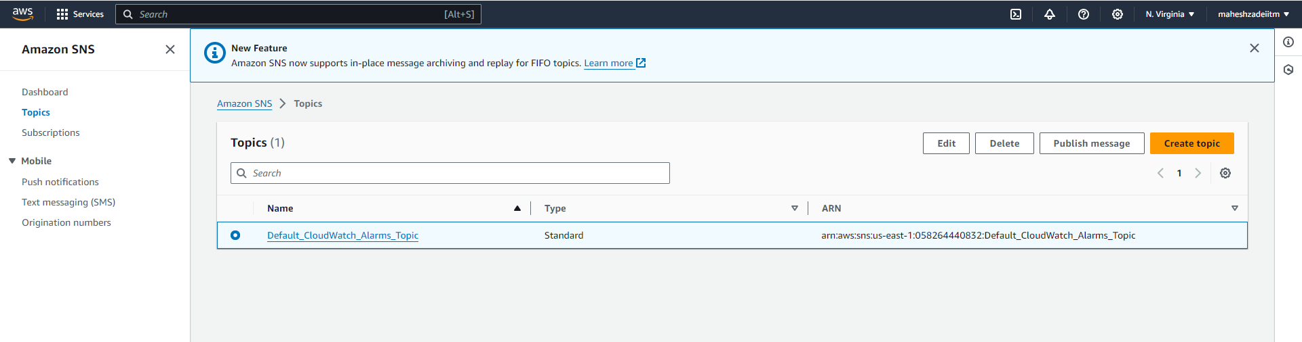

It is reflected in IAM Dashboard.

Whenever the CPU Utilization crosses 65%, it notifies the subscribed user by sending an e-mail.

This completes our assignment.

Thank you